PIXEL PIRATE PACK
BY STEFAN JOVANOVIC

SPRITES
Sprites are separated into 6 different categories:
- Characters
- Props
- Ship
- UI
- Water
- Weapons

CHARACTERS
There are 3 character spritesheets, each containing 4 animations: Idle, Run, Hurt, Die. Single sprite size is 32x32.
Alongside spritesheets come hand and shadow sprites.

PROPS
Props include:
- Barrel (32x32 px)
- Blood particle (16x16 px)
- Crates (48x90 px)
- Health potion - spritesheet (single sprite is 32x32 px)
- Pirate coin – spritesheet (single sprite is 18x18 px)
- 2 Sails
  - Sail 01 (120x119 px)
  - Sail 02 (89x151 px)
- Ship Rudder and Rudder(interactable) – 32x32 px
- Ship hole (32x32 px)

SHIP
Ship comes in three parts that should have different sorting layers:
- Front part of the ship
- Back part of the ship
- Ship shadow

UI
Elements included:
- Button (clicked and unclicked) – 46x12 px
- Close button (clicked and unclicked) – 14x14 px
- Health bar parts:
  - 2 health bar spritesheets (single sprite is 48x12 px)
  - Up, Down, Left and Right border
  - Animated skull
- Text cloud

Water
There are 3 water spritesheets included. Water above the ship, water below the ship and ship wave.

Weapons
There are 3 weapons included: pirate gun, enemy sword, player sword.

Animations and animators
Each character has an animator that is an overview of all the animations. Other than that Player animator is also included. Character animations and weapon animations are separated, so that characters can have various weapons without need for additional animations, There are also various other animations and animators for props, ship, water and UI.

Scripts
There are total of 4 scripts included:
- PlayerController
- SmoothCameraFollow
- SortByY
- Weapon

Player Controller
Player controller is responsible for the player movement. It only takes speed as the parameter.
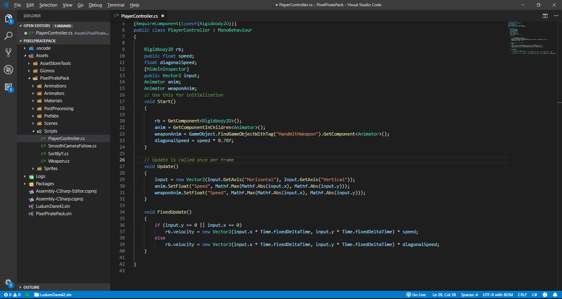
It uses Vertical and Horizontal Input axis as the input for the up-down and left-right input(Image below).

It also takes care of the diagonal movements, so that the diagonal speed is not greater than the horizontal and vertical speed. Movement is achieved by directly changing the velocity of the Rigidbody2D(Image below).

Smooth Camera Follow
Smooth Camera Follow takes target to be followed and virtual camera as the arguments. You also need to set the X and Y bounds of the camera(their minimum and maximum value).

Sort By Y
Typical sorting in Unity is done relative to the Z axis and this script changes the relative axis to the Y axis. This approach is useful for topdown 2D games.

Weapon
Weapon script is used to control the weapon of the player by flipping the player relative to the mouse position and also triggering the appropriate animation for the current state.
It takes Player prefab, Weapon animator and Weapon collider as arguments.

Contact
Email: sjovanovic0831@gmail.com
Twitter: https://twitter.com/SJovGD
Blog: stefanjoblog.wordpress.com

